Getting Started

System Requirements

Windows
- Operating System – Microsoft Windows XP or higher
- Software :
  - Microsoft Windows Installer 3.1(required only for Windows XP). You can download it from http://www.microsoft.com/downloads/en/details.aspx?familyid=889482fc- 5f56-4a38-b838-de776fd4138c&displaylang=en
  - Java(TM) SE Runtime Environment 1.6 . You can download it from http://www.oracle.com/technetwork/java/javase/downloads/index.html
  - Microsoft .Net Framework v3.5. You can download it from http://www.microsoft.com/downloads/en/details.aspx?FamilyID=d0e5dea7-ac26-4ad7-b68c-fe5076bba986

Linux
- Operating System – Ubuntu 10.4 or higher
- Software:
  - Java(TM) SE Runtime Environment 1.6 for Linux http://www.oracle.com/technetwork/java/javase/downloads/index.html
or,
You can download and install in Ubuntu using the command
sudo apt-get install openjdk-7-jre

OS X
- Operating System – Any OS that supports Java(TM) SE Runtime Environment 1.6 or higher
- Software :
  - Java(TM) SE Runtime Environment 1.6 for Linux http://www.oracle.com/technetwork/java/javase/downloads/index.html

Installation
Zug can be installed in Windows, Linux and OS X. In this section we will walk you through the step by step installation procedure.

Windows
- To install zug on windows, download the installation file from the website www.automature.com
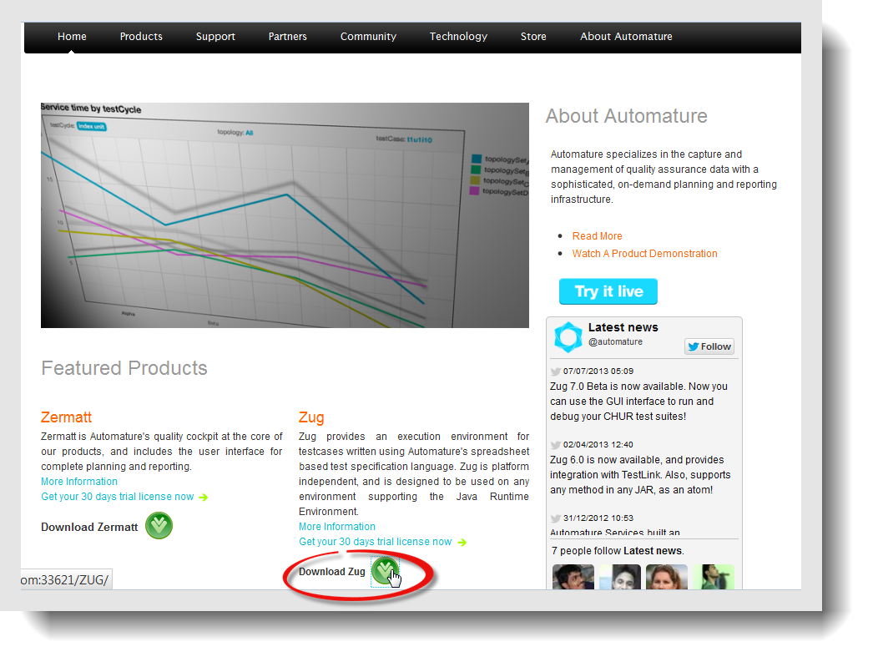
- Download installZug.jar file and save it in a location in your computer.

- To begin installation, type the following at the command prompt.

java -jar installZug.jar

Note: It is strongly recommended that you have the administrator privileges over your machine to run the Zug installer.

- The first welcome screen of ZUG is displayed. On clicking Next, the ZUG Setup Installation wizard will guide you step by step through the installation procedure.
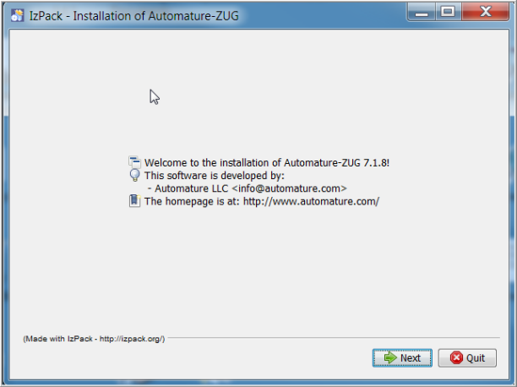

- Zug Release Notes is displayed in the next screen. It lists the enhancements, bug fixes and the known issues in this version. Click Next.
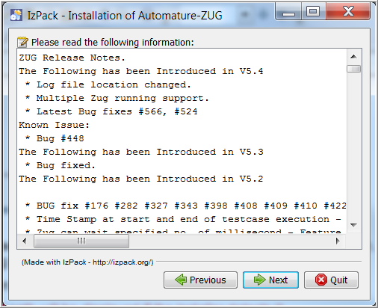
- You will be able to view the EULA. If you agree, check the radio button 'I accept the terms of this license agreement' the Next tab gets highlighted.
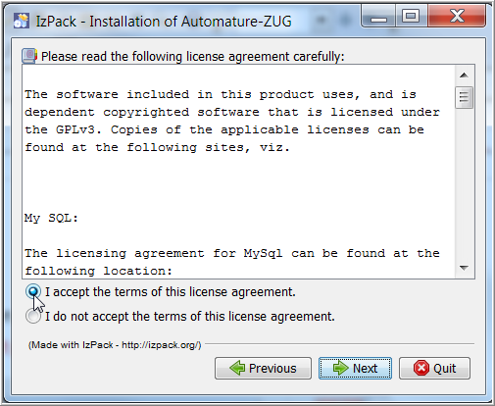

- In the next screen browse and select the destination folder path. The default path is set to
C:\Program Files\Automature.
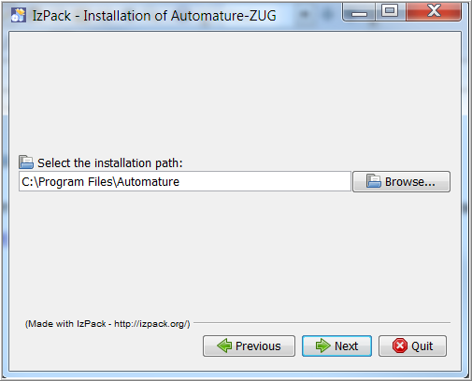
- On clicking Next a message prompt appears informing that the target directory will be created in this path. Select OK.
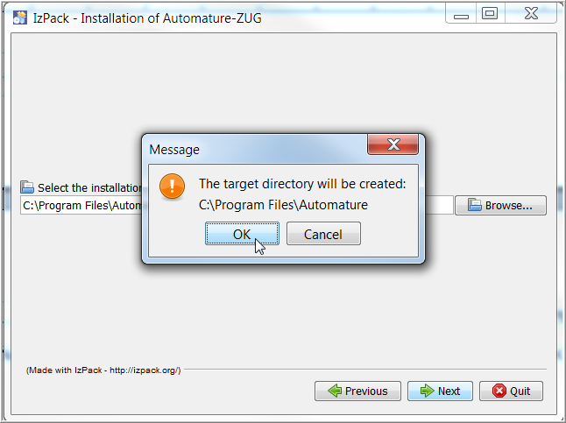

- Click Next to start the installation.
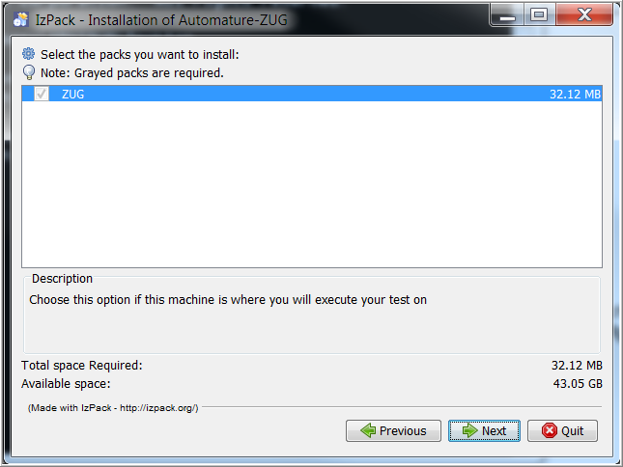

- In the screenshot below, you can see the two parallel bars tracking the installation process. Click Next to continue.
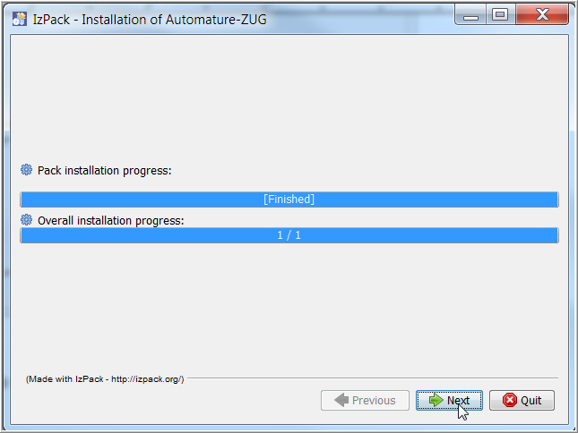
- The next screen confirms that that installation has been completed successfully.
Note: You can generate an automatic installation script and save it in any location of your choice by clicking the Generate an auto installation script tab. The objective of this is to automatically install the application in other machines with same configuration.

- Copy and paste Zug License.Key in the Zug folder.
- Now you can launch the Zug GUI, type the following at the command prompt.

zug -gui

OS X

- For installing ZUG in MAC you need to download installZug.jar from Automature website (www.automature.com) and save it in a preferred location.
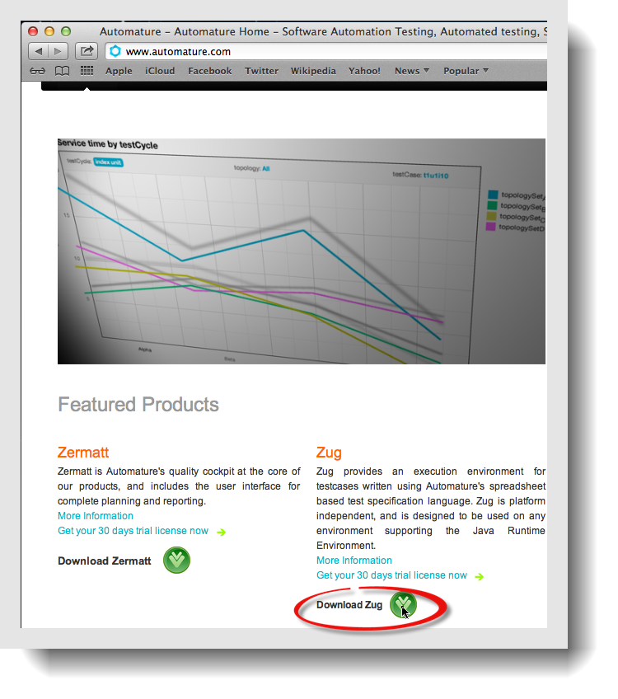

- Save the file in a desired location.

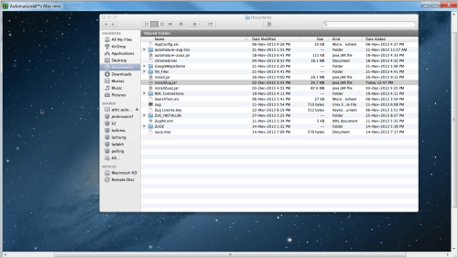
- To start the installation process run the following command in sudo mode.
sudo java -jar installZug.jar

- Click Next to continue the installation.
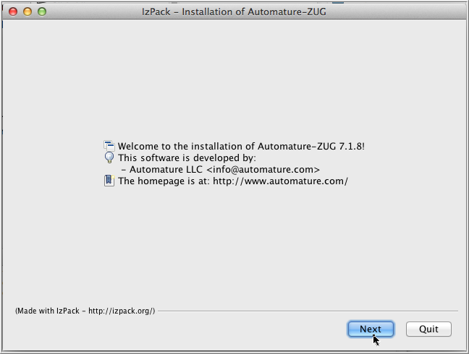

- Zug Release Notes lists the enhancements, bug fixes and known issues in the version. Read the information carefully and select Next to proceed.
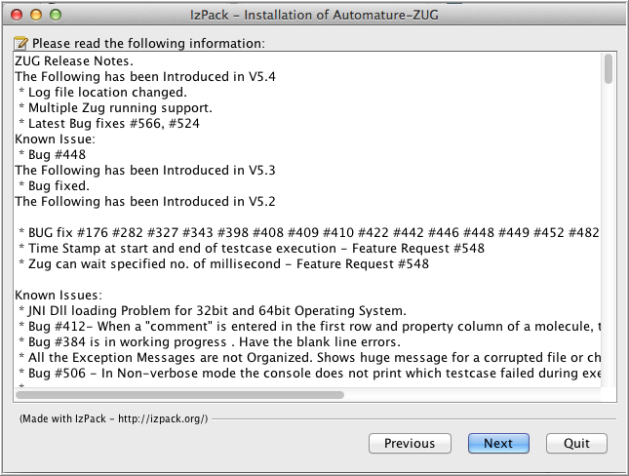

- Read the EULA carefully and check the radio button 'I accept the terms of this license agreement' to continue the installation. At this point if you want to discontinue the installation process check the radio button 'I do not accept the terms of this license agreement.
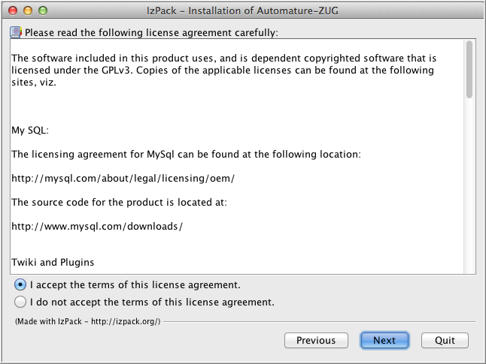

- Browse and select the installation path. The default installation path is /Applications/Automature-Zug.
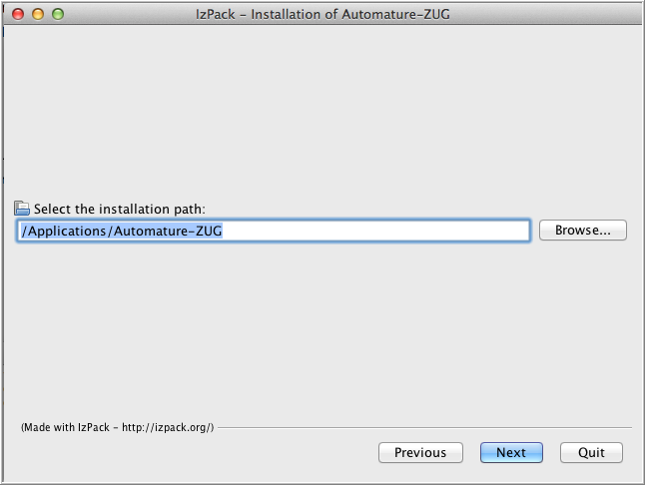

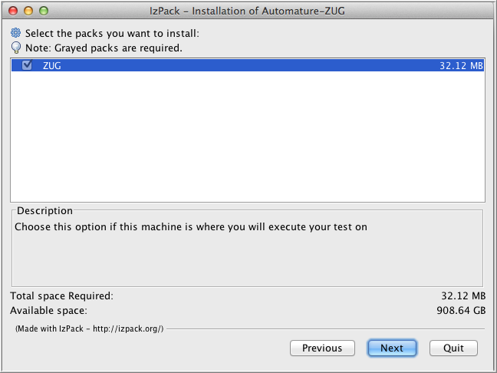
- Click Next to complete the installation.

- The two progress bars tracks the completion of the installation.
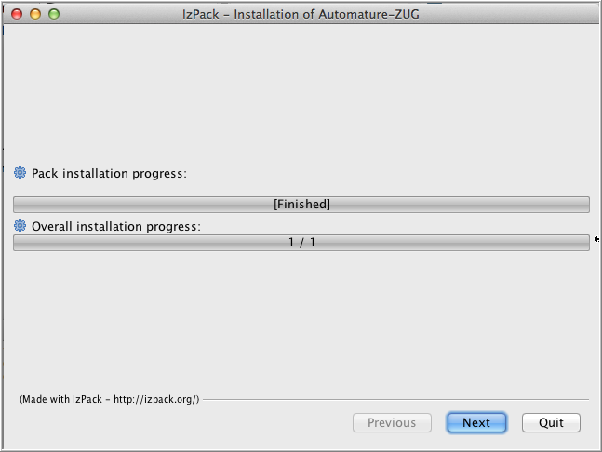
- This screen confirms that the installation is successful. You can generate an auto-install script by clicking the tab Generate an automatic installation script and save it in a preferred location. This automated script can be used to install Zug in other machines.
Click Done.
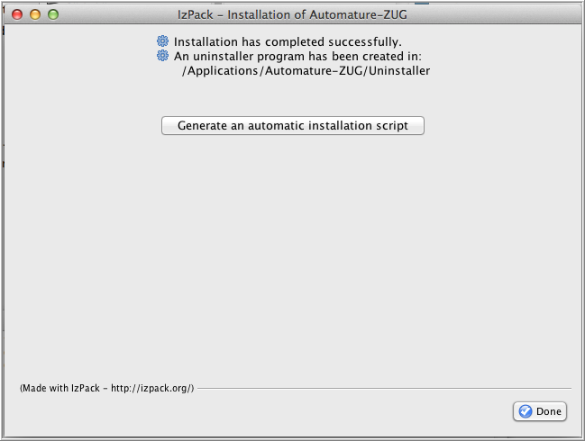

- Now that you have completed the installation, you can launch Zug GUI from the command prompt by typing:

Zug -gui

Linux
- For installing ZUG in Linux you need to download installzug.jar from our company website (www.automature.com) to a desired location.
- Extract and save the files in the path usr>lib>automature.
- To start the installation process run the following command in sudo mode.
java -jar installZug.jar

- Click Next to continue the installation.
- Zug Release Notes lists the enhancements, bug fixes and known issues in the version. Read the information carefully and select Next to proceed.
- Read the EULA carefully and check the radio button 'I accept the terms of this license agreement' to continue the installation. At this point if you want to discontinue the installation process check the radio button 'I do not accept the terms of this license agreement.
- Browse and select the installation path. The default installation path is /Applications/Automature-Zug.
Click Next to complete the installation.
- The two progress bars tracks the completion of the installation.
- This screen confirms that the installation is successful. You can generate an auto-install script by clicking the tab Generate an automatic installation script and save it in a preferred location. This automated script can be used to install Zug in other machines.
- Click Done.
- Now that you have completed the installation, you can launch Zug GUI from the command prompt by typing:

Workspace

Overview

Menus
The Zug menu-bar is anchored on the top left corner just below the title bar of the GUI. It lists various menus that can be selected. It displays the headings for each drop-down menu. Commands are grouped under each of these menu headings according to the function.

File

- Open : Opens a file.
- Exit : Closes all open files and exits the GUI.

Edit

- Context Variables : Modify context variables.
- Break point : Modifies break points inserted in a test suite.

View

The View menu allows you to view your workspace in different ways depending on the task at hand. The menu options have a check box beside them. Select the check boxes beside the components you want to view. By default the Console and the Command line is checked so that they are displayed when the GUI is launched.

Test Suite and Debugger Controls gets activated after you have loaded a test suite else they are disabled.

- Console
- Test Suite
- Command Line
- Debugger Controls
- In-process atoms

The in process atoms can be viewed if the in-process package for Automature Zuoz has been loaded.

Run

Run menu houses all the commands which can be used when running test cases.

- Execute : Executes a selected test case.
- Pause : Pause a running test case
- Stop : Stops a running test case
- Step :
- Resume : Resumes running a test case which has been paused.

Options

- Mode : The three modes available are

Production : This mode runs test cases in unattended mode and reports results to Zermatt.
Performance: This mode executes a test case to test the performance parameters, values and attributes.
Development: This mode is used by the developer for debugging automated scripts when a test case is being executed.
- Verbose : This optional mode displays varying levels of status messages in the output console when a test case is executed.
- Autorecover: This mode automatically handles exception when a test case encounters a crash or a freeze when run.
- NoVerify : This mode executes test case without any verification.

Reporting

Zug can report to Zermatt that show statistics or performance indicators for a particular TestCycle, TestPlan and TopologySet. This can be configured using the menus available under reporting.

- TestCycle
- TestPlan
- TopologySet

Help

- Contents : Opens up the Zug User Manual in PDF version in a separate window.
- Automature Website : Opens the Automature website in a new window.
- About : Displays version and license information.

ToolBar
Zug GUI tool bar is located just below the menu bar. The icons in the toolbar serve as an always available, easy-to-use interface for common functions such as loading a test suite, running a test suite, reloading a test suite without having to search through the drop-down menu.

More Options
Toggle Property Bar display
Production Mode
Show Console only

Reload test suite file
Development Mode
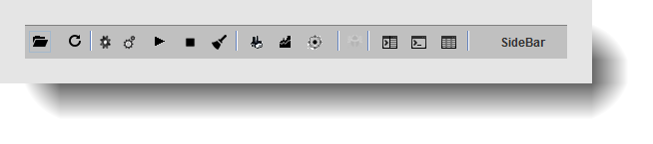
Stop

Browse test suite file
Options
Execute test
Clear
Performance Mode
Split the display
Show sheet only

Sheet View
Zug GUI allows you to customize how you view your workspace hiding or displaying sheets with the help of icons in the toolbar.
Split View
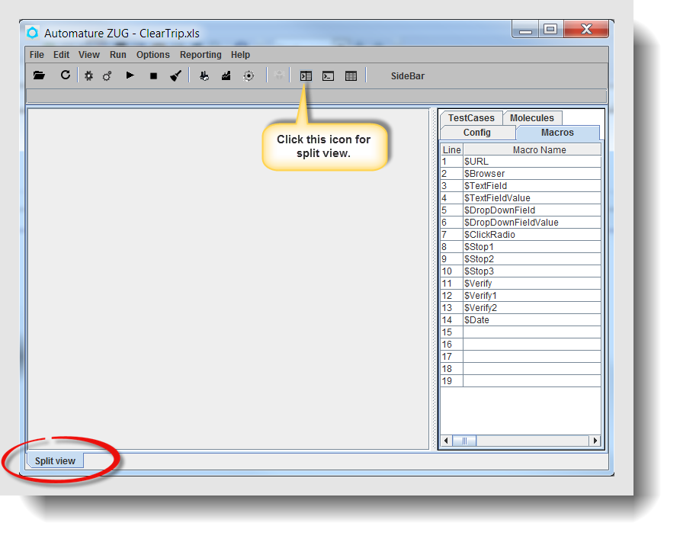
To split the display click from the toolbar. The split view divides your into two equal parts displaying the console and the loaded test suite.

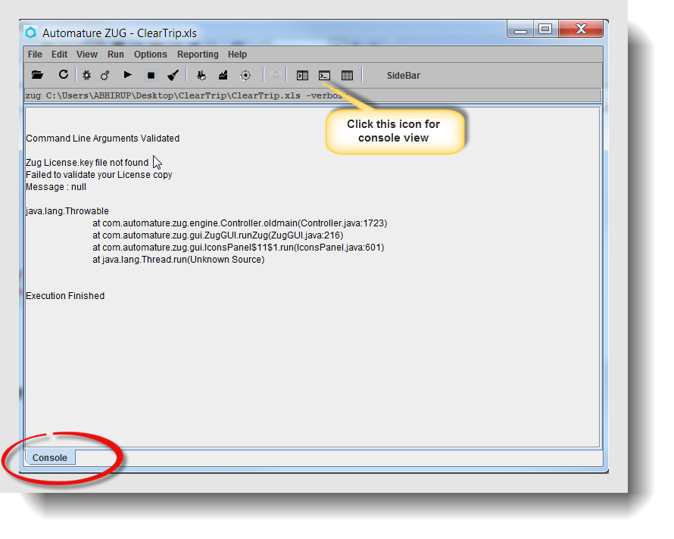
Console View
This view displays only the console output.

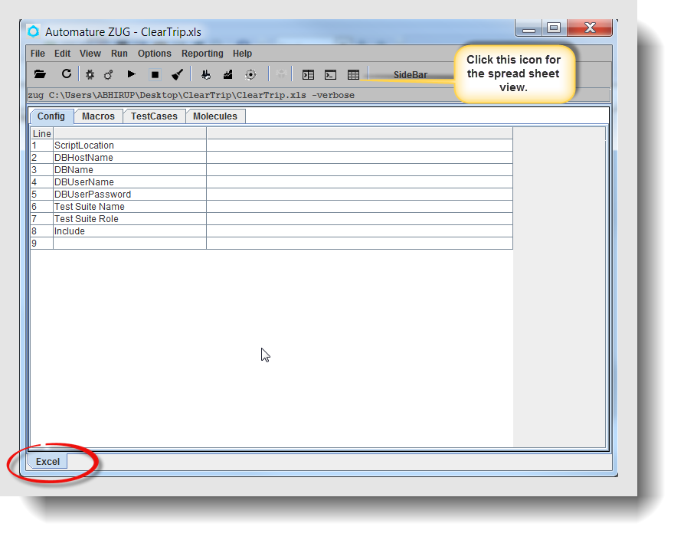
Sheet View
This view displays the spreadsheet with the test suite written in CHUR.

